|  |  |
| --- | --- |
| *Pacific Gas and Electric Company* | |
| Settings 0.2 Installation Guide | |
|  |  |
|  |  |
| Project | ED AM/GIS – Settings Application Deployment |
|  |  |
| Prepared by | Chris Kim |
| Date | 8/5/2014 |
| Version | 0.4 |
| Version Type | Draft |

|  |  |  |  |
| --- | --- | --- | --- |
| Revision History | | | |
| Document # | Date | Author | Summary of Changes |
| 0.1 | 4/21/14 | Chris Kim | Initial Document Creation |
| 0.2 | 6/25/14 | Chris Kim | Added Setting Utility |
| 0.3 | 8/1/2014 | Chris Kim | Added DB Password Update for Production |
| 0.4 | 8/5/2014 | Chris Kim | Added stopping the default web site. |

# Introduction

## Purpose

This document is intended to detail the implementation and configuration steps required to implement the Settings Management Application. This document describes the various configuration aspects required to complete the application installation steps for this release.

## Terms Used

|  |  |
| --- | --- |
| OOTB | Out of the box. Unmodified from the commercial version. |
| TFS | Team Foundation Server |
| DB | Database |
| IIS | Internet Information Services |
|  |  |

## External Documents

Referenced are any external configuration documents or exports. These are documents that contain more detailed information about configuring a system or documents that can be loaded into an application to perform the configuration detailed in this document.

## List Of Fixes

Below is the list of change requests detailing all fixes for this release:

|  |  |  |
| --- | --- | --- |
| **Item Number** | **Title** | **Work Item Type** |
|  |  |  |
|  |  |  |
|  |  |  |

## Summary of Steps to Complete Installation

These are the high-level steps to complete the installation and configuration of the Settings Management application. Use this table as a guide for completing the installation. Links are provided that can lead either within the document for detailed explanations or to external sites such as Sharepoint.

|  |  |  |  |
| --- | --- | --- | --- |
|  | **Step Name** | **Description** | **CR (if applicable)** |
|  | General Section |  | - |
|  | IIS Configuration | Configure the Internet Information Services in the web server. | - |
| 3. | Web Application Deployment | Copy the solution files to website. |  |
| 4. | Utility Application Deployment | Copy the solution files to a file directory. |  |
| 5. | Update Production Database Password | Update to production database password in the application configuration file. |  |

# IIS (Internet information services) Configuration

1. Create App Pool.
   1. 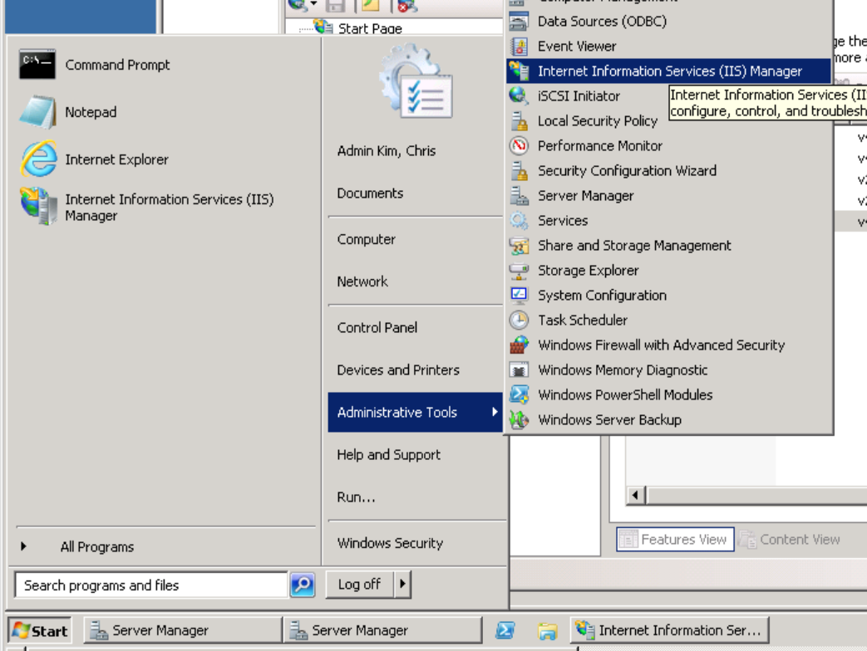Go to start, then administrative tools/Internet information services (IIS) Manager
   2. Expand the server name on the left hand side, then right click on the “Application Pool”, then select the “Add Application Pool”
   3. Put “SettingApp” as the application pool name and select the .NET Framework version 4.0.30319.

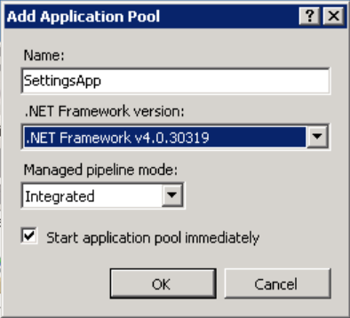

* 1. 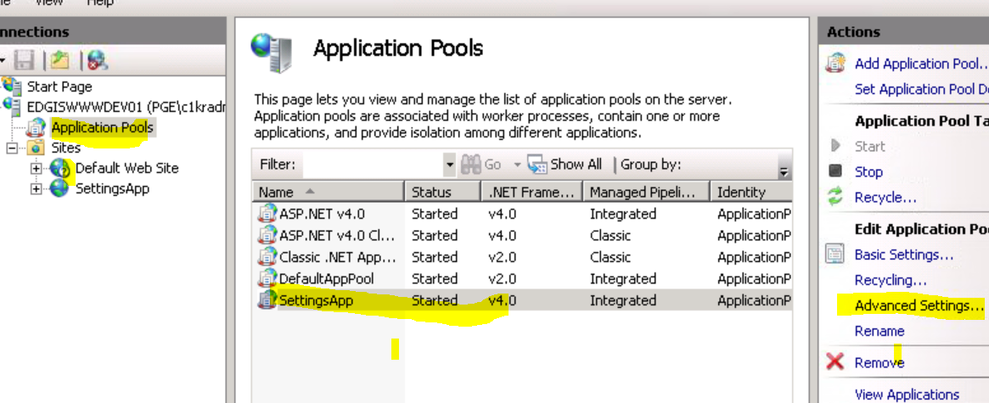Once the app pool is created, select the “SettingsApp” in the mid section of the window, and then click on the “Advanced Settings” on the right.
  2. Click next to “Identity” to open the identity selection window.

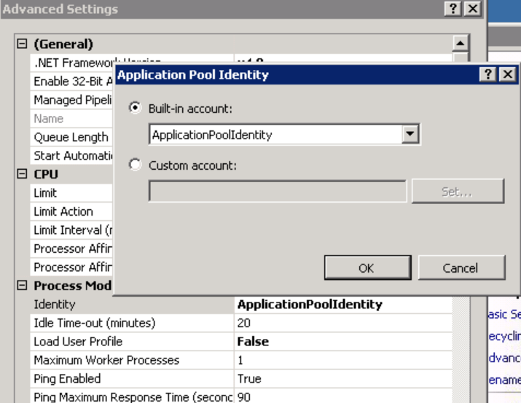

* 1. Click on the Set for the “Custom Account” and put user name as “SVC_ED_SettingsApp” and provide the password “”.

1. Create a website as follows,
2. Expand the the server and right click on the “Site” and select “Add Web Site”

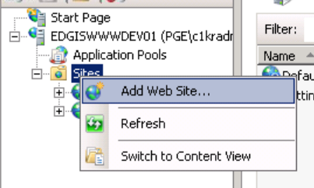

1. Put “SettingsApp” as the site name and then choose “SettingsApp” as the application pool. For the physical path, put “D:\inetpub\SettingsApp”.

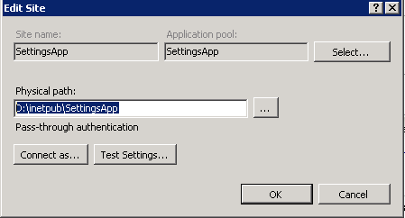

1. Double click on the “Authentication” under IIS section

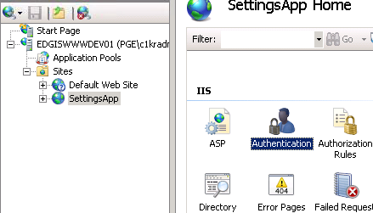

1. Configure to following:

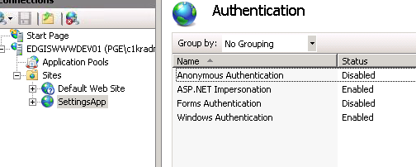

1. Disable “Default Web Site”
   1. Click on the “Default Web Site”

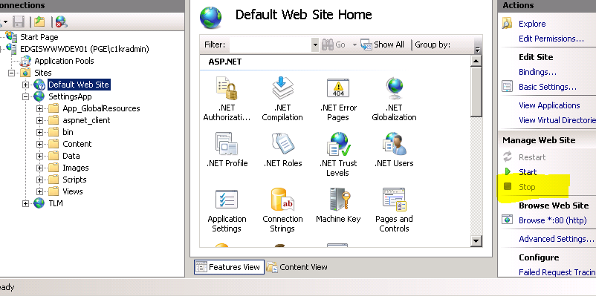

* 1. Take a look at the “Manage Web Site” section, and if “Stop” is enabled, click on the link to stop the web site.

# Deployment of Settings Web Application

1. Navigate to \\sfetgis-nas01\sfgispoc_data\ApplicationDevelopment\IBM_Delivery\Settings\WebApplication.
2. Find the approporiate environment, dev, test, stage, prod.

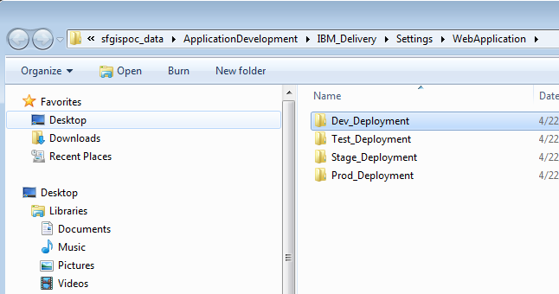

1. Copy to the location defined in the IIS setting, to “D:\inetpub\SettingsApp”.

# Deployment of Settings Utility Application

Copy the contents from the source folder to the target folder.

Source:

\\sfetgis-nas01\sfgispoc_data\ApplicationDevelopment\IBM_Delivery\Settings\Utilities\Test_Deployment

Destination

[\\edgiswwwtst01](https://webmail.pge.com/owa/redir.aspx?C=qmhGNI1JQUqxHOJ6NA4qRrjGTklhONEIL_DvDORgfbB1jcl1cq0wlpKzRSyb-KCE4PXGBHwsrgg.&URL=file:///%5c%5cedgiswwwtst01), D:\inetpub\SettingsApp\SMUtilityExport

(** \\edgiswwwtst01 is a target for the testing environment, use the approporiate servers for different environments.)

# Updating Password for the Production

This section will explain how to update the database password for the production environment.

1. Navigate to the source deployment location

(example: \\sfetgis-nas01\sfgispoc_data\ApplicationDevelopment\IBM_Delivery\Settings\WebApplication\1.0.0.4\Prod_Deployment)

1. Locate existing database connection entry and delete that whole line.

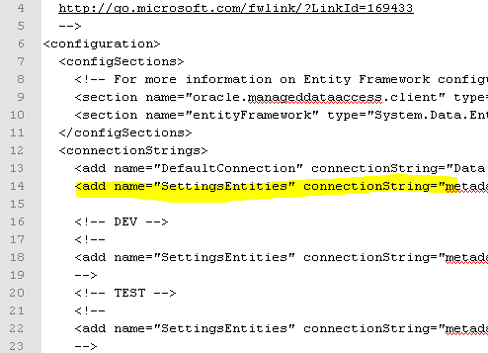

1. Locate the production entry that is commented out. “<!- -“ is start of comment and “- - >” is end of comment.

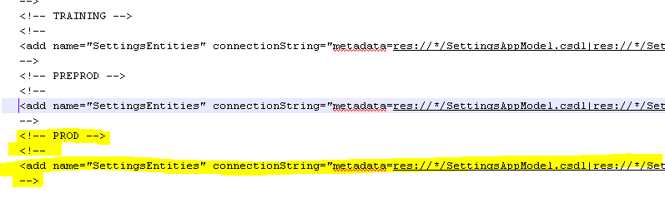

1. Copy the line that starts with “<add name=”SettingsEntries” connection….”
2. Paste to the location that was removed in step 2.
3. Locate the password attribute in the entry.



1. Change the password to production password and save.

# Known Issues

<Please List any other issues encountered here while following the document>